
IMPORTANT INFORMATION RE PARKING ON SITE
Please ensure all your guests are aware there is a managed Car Park on site, and any vehicles parked on the access road, within hatched areas, and in parking bays marked 11 TO 29, will receive a parking charge fine of £100.
If the car park is full there is plenty of alternative parking, which are easily accessible, and just a few minutes walk from the building.
There is pedestrian access from Elm Grove onto the Business Park.
The Car Park at the Fire Station is free, as is all the street parking in the area.
Please see attached map for parking locations.
The LBP Management have also asked that no one parks on double yellow lines, or on the bend on the Chartwell Road, as it is a working business park, and traffic needs to be able to flow freely, whilst also ensuring the safety of everyone visiting the Business Centre. Please ensure everyone is exiting on the pavement side.
This situation is entirely beyond our control, and one that has been implemented entirely by the Landlord, and we truly hope it will not impact on your visit to Wickers Gymnastics Club.

Please see alternative parking within a 3 minutes walk from our facility, and all free of charge.
Don’t forget there is also pedestrian access from Elm Grove onto the Business Park.
1. On-site outside Wickers
2. Street parking along Chartwell Road
3. Street parking along Elm Grove, accessed via Chester avenue from the A259.
4. Public Car Park, next door to the fire station
5. Street parking along Norton Road (just past the play park)

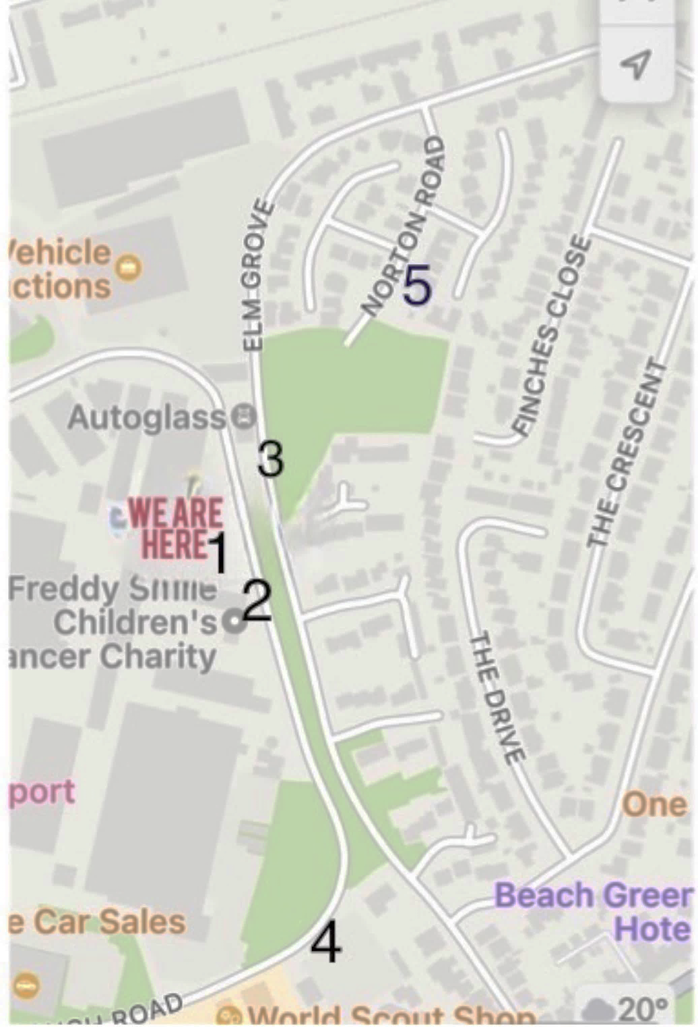
Please be mindful of other businesses on the park, and please do not stop or park on the double yellow lines.

